No11 (RAAF) P.D.R.C (SPECIAL ADMIINISTRATIVE SECTION) R.A.F STATION, BRIGHTON
STATEMENT OF ESCAPED, EX-INTERNEE, REPATRIATED P.O.W., RELEASED P.O.W.
Number. Aus/ 404137 Rank. W.O. Name. BELL J.R
Squadron 216 Maisto**ng W.A.G Course 2-E.A.T.S
1. Particulars of operation ** ***** ******.
I was the W.A.G (*******)
Fly to
Detailed to attack & target at…………………MSUS. Libya (name of target) on
the 23-1-42 (date)
2. Circumstances of the loss of aircraft
Give details of what occurred paying particular attention to (i) cause of damage
to aircraft (ii) Orders *** by captain to abandon A/C and if acknowledge by crew.
(iii) Details of injuries to : *** members, and if so whether unable to bale out.
(iv) The identity of members who baled out up to time of your leaving aircraft.
(v) The number and identity of any members of crew who you know to have still been
in the aircraft when you left it. (vi) Height at which you baled out. (vii) Whether o
or not aircraft was in control at that time, and its condition whether on fire etc.
(viii) Approx where did aircraft crash.
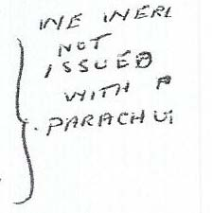
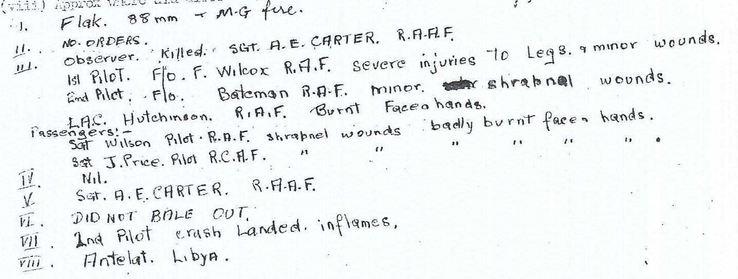
3. Probable fate of other members of crew.
(include whether ** parachutes in the air, made contact with other members on the ground, or received any information regarding them from any source whatever:
any details of burials etc.